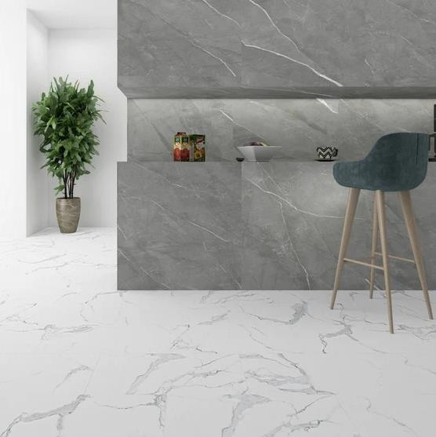
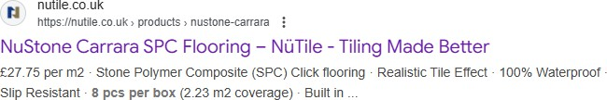

308 x (8pcs per Box which equals 2.23m2) NuStone Carrara SPC Flooring – Stone Polymer Composite (915mmx305mm) RRP
(£61.89 per box of 8pcs)

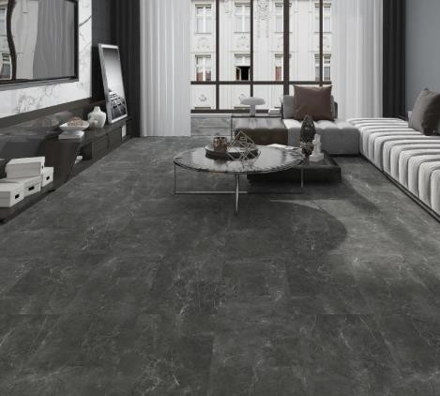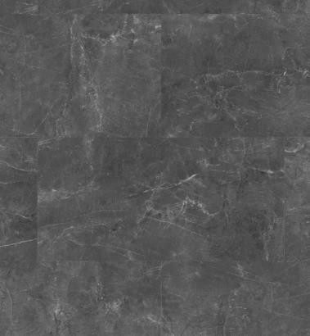

223 x (8pcs per Box which equals 2.23m2) NuStone Black Marble SPC Flooring – Stone Polymere Composite (915mmx305mm)…………RRP (£61.89 per box of 8pcs)……

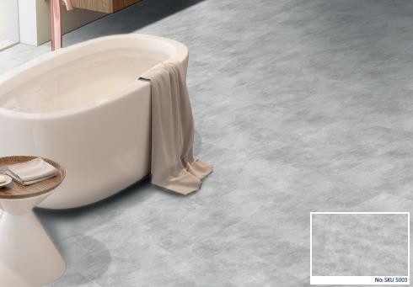

77 x (8pcs per Box which equals 2.23m2) NuStone Concrete SPC Flooring – Stone Polymere Composite (915mmx305mm) RRP
(£61.89 per box of 8pcs)
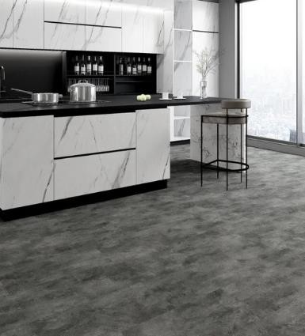

130 x (8pcs per Box which equals 2.23m2) NuStone Dark Concrete SPC Flooring – Stone Polymere Composite (915mmx305mm)…………RRP (£61.89 per box of 8pcs)………
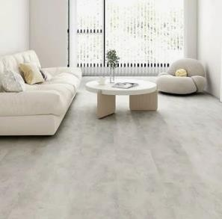
104 x (8pcs per Box which equals 2.23m2) NuStone Beige SPC Flooring – Stone Polymere Composite (915mmx305mm) RRP
(£61.89 per box of 8pcs)……

